PRESS RELEASE: Wednesday 13th October 2021
For Press Use :: ‘Chase the Moon’ (single) by Mike Hanrahan
Press Stream / Download audio: https://song.space/6pfl23
Duration: 03:51mins
Independent Release
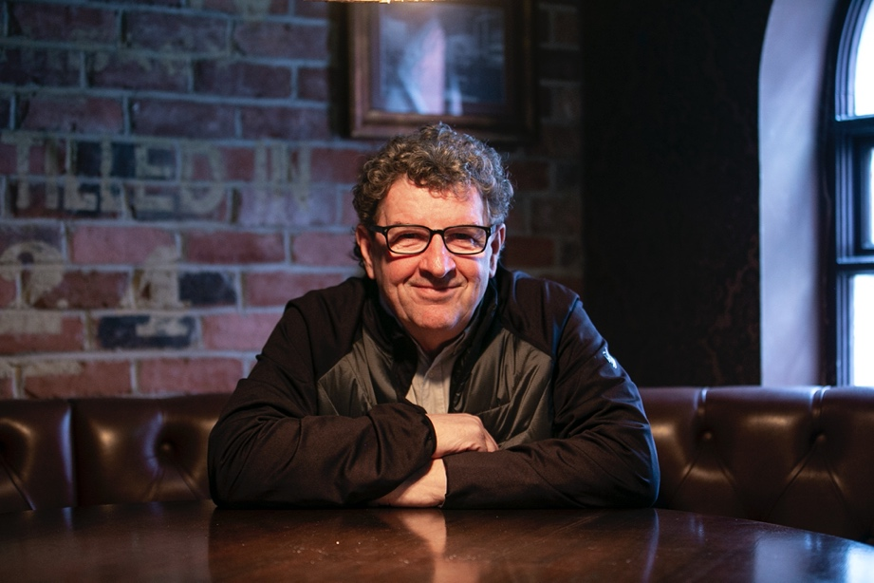

CO. CLARE SINGER-SONGWRITER, GUITARIST
MIKE HANRAHAN (STOCKTON’S WING)
LAUNCHES HIS FIRST SOLO SINGLE
‘CHASE THE MOON’

Taken from his forthcoming solo album “Songs from the Box Room”,
which is set for a 2022 release

+ upcoming tour dates announced

Having spent over four decades performing with legendary acts Stockton’s Wing, Ronnie Drew, Maura O Connell, Eleanor Shanley, and Leslie Dowdall, County Clare singer-songwriter and guitarist Mike Hanrahan is back out on his own, singing new songs from isolation, sharing gems from his very successful back catalogue, and a whole bunch of stories from his critically acclaimed memoir “Beautiful Affair: A Journey in Music, Food and Friendship”.

Earlier this year, during lockdown, Mike shared a recording of his song by The Forgetmenots Choir. Penned by Mike, ‘A River Rolls On’ was inspired by his mother’s slide through the phases of vascular dementia, and imagining her life as a beautiful meandering river starting high in the mountains, nourishing many, giving so much to the world as it gently rolls to the sea. All proceeds from this song went to Dementia projects.

Mike Hanrahan now shares ‘Chase the Moon’, the first song from his forthcoming album “Songs from the Box Room”, which is set for a 2022 release.
“Chase the Moon was originally inspired after talking to an old friend who was quite apprehensive about an impending medical procedure. It began as a personal word of encouragement, and then lockdown introduced me to a global audience on my daily Facebook livestream #cookingupastorm. We were all struggling on a rocky ocean heading for that distant dry land. The song soon evolved and the line “Let mercy be the wave that takes us home” became our daily mantra as we talked food and music across several timelines.”
Hanrahan has spent decades writing and releasing songs with other artists, and now is stepping out with his own solo project. Speaking about how it came about, he says:
“I spent all of last year on my own in my little box room homemade recording/ writing space. I reconnected with the writer I had left somewhere on the roadside. The songs and tunes kept coming and I decided to record another album. It has been almost twenty years since I released my own music. The time seems just right. The music business has certainly changed but people will always want to listen to new music. I have songs and a story to tell and I really look forward to sharing it all.”

‘Chase the Moon’ by Mike Hanrahan, is out on Bandcamp and Spotify Wednesday 13th October 2021.
https://mikehanrahan.bandcamp.com/releases
https://open.spotify.com/track/3uE6ox2d5fYp6ZGU9e8ISZ?si=98910a6ba6c54cef

See Mike perform his new songs and old favourites, live:
- October 21st Gigs in The Garden Room, Sage Midleton, Cork, 6pm. To book, phone 021 4639 682

- October 28th Bob’s Hideout, Durrow, Co. Laois. Ticket link: https://www.bobsbar.ie/events/an-evening-with-mike-hanrahan?fbclid=IwAR1UDPZANzWprAqHGeCk7hpFLEdE8_J3y9byqctR3a3waxUxhOJMoggBcBk

https://www.instagram.com/mikehanrahanmusic/
https://www.facebook.com/dinkyhanrahan/
https://www.facebook.com/mikehanrahan46
https://twitter.com/mikehanrahan58

https://mikehanrahan.bandcamp.com/releases

https://www.youtube.com/channel/UC_j8ficIJ3bH2wK-91-xxmg

www.mikehanrahan.com

ENDS
For Press Use :: ‘Chase the Moon’ (single) by Mike Hanrahan
Press Stream / Download audio: https://song.space/6pfl23
Duration: 03:51mins
Independent Release

Press contact: Louise Barker | louise@kearneymelia.com | 087 773 4241

